# Personal Medical Assistance

**MOHAN PRADEEP RAJA**

**Date: 04/07/2016**

# Personal Medical Assistance

Table of Contents

Personal Medical Assistance 1

Personal Medical Assistance 2

PART 1: DESCRIPTION OF THE PROJECT 4

PART 2: MAIN MENU THE ROLES – (PLANNING PHASE) 4

PART 3: CLASS DESCRIPTION – (PLANNING PHASE) 5

PART 4: UML DIAGRAM – (DESIGN PHASE) 6

PART 6: ER DIAGRAM - (DESIGN PHASE) 7

PART 5 : DEVELOPMENT PHASE 8

LOGIN SCREEN 8

HOW TO RUN 9

LOGIN SCREEN 10

DOCTOR PORTAL 11

ADD PATIENT 12

RECORD ADDED 13

VIEW PATIENTS 14

UPDATE PRESCRIPTION FROM TABLE 14

PRESCRIPTION UPDATE 15

VIEW PRESCRIPTION 16

VIEW MEDICINE REVIEW 17

WRITE PRESCRIPTION – ENTER PATIENT ID 18

DISPLAYING DETAILS OF THE PATIENT 19

PATIENT LOGIN 20

PATIENT INTERFACE 21

VIEW YOUR PRESCRIPTION 22

VIEW UPDATE PROFILE 23

UPDATE DONE 24

VIEW FAMILY PRESCRIPTION 25

WRITE REVIEW 26

VALIDATIONS : 27

CUSTOMER ADDING 28

# PART 1: DESCRIPTION OF THE PROJECT

It is a health tracking system where a family can keep track of the medicine that has to be taken and the family members can view the prescribed medicine which has to be taken-in every day and doctor can check the patient history maintain the patient health and update the medicine based on the health status. Family can consult doctors by setting up meeting with the doctor through the app.

I developed an end to product in core Java using OOP concept of development and used MySQL as my database. Modelled database in such a way to store data and retrieve it back efficiently. To maintain proper code reusability and making decoupling of major components from each other I Implemented the complete project following MVC Architecture.

XML Parsers (DOM and SAX) are created to load the initial set of data to MySQL Database from XML.

Used Hibernate frame work to implement the ORM in an object-relational mapping, by providing mapping of object-oriented domain model to a relational database

There are two major roles in the project

* Doctor
* Patient Related by family

# PART 2: MAIN MENU THE ROLES – (PLANNING PHASE)

* Doctor
  + login
  + create patient record
  + update patient prescription
  + view the prescription
  + create treatment details
  + logout
* Patient
  + login
  + view prescription
  + view family member prescription
  + write Review medicine
  + logout

# PART 3: CLASS DESCRIPTION – (PLANNING PHASE)

* Prescription is the parent class which has the child class which inherits the properties this class.
* DocInt is the interface which implemented by the doctor and the PatientInt interface is implemented by the patient class
* Prescription class is the parent class which is used to find the patient details which is inherited by the doctor and patient class
  + prescriptionDetail()
* methods in doctor class will create patient, add prescription, review medicine
  + selectPatient()
  + prescriptionDetail()
  + createPatient()
  + addPrescription()
  + writeReview()
  + deletePrescription()
  + viewReview()
* methods in patient class will view prescription, contact doctor, write review for medicine
  + selectPatient()
  + prescriptionDetail()
  + viewPrescription()
  + writeReview()

# PART 4: UML DIAGRAM – (DESIGN PHASE)

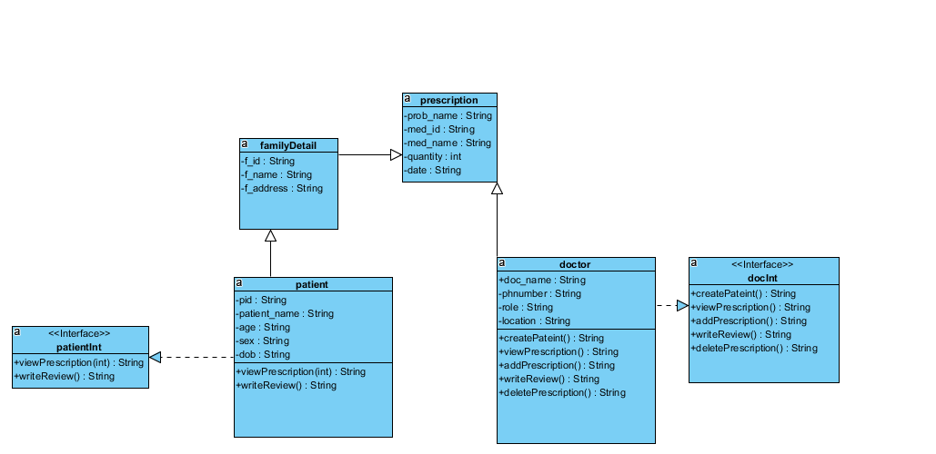

# PART 6: ER DIAGRAM - (DESIGN PHASE)

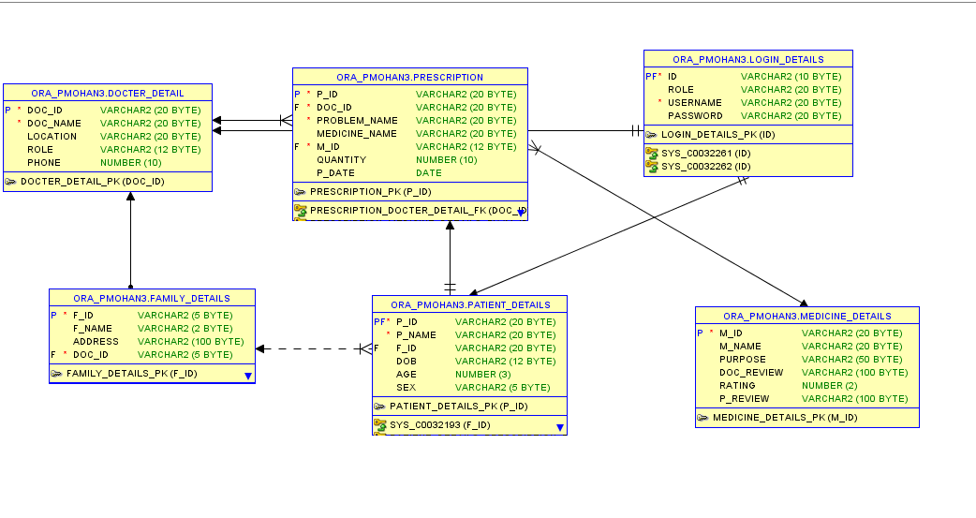

# PART 5 : DEVELOPMENT PHASE

## **LOGIN SCREEN**

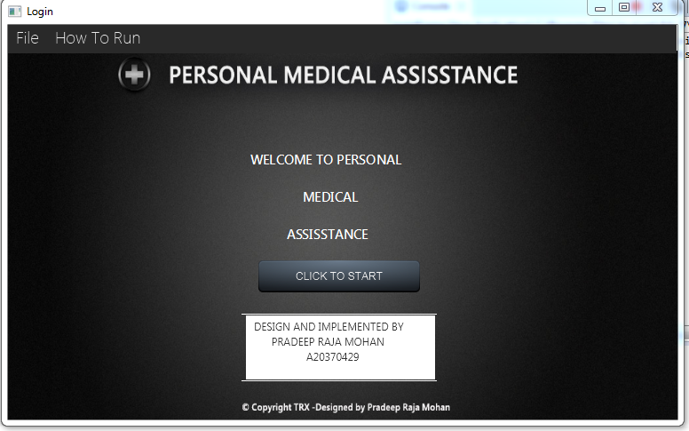

## **HOW TO RUN**

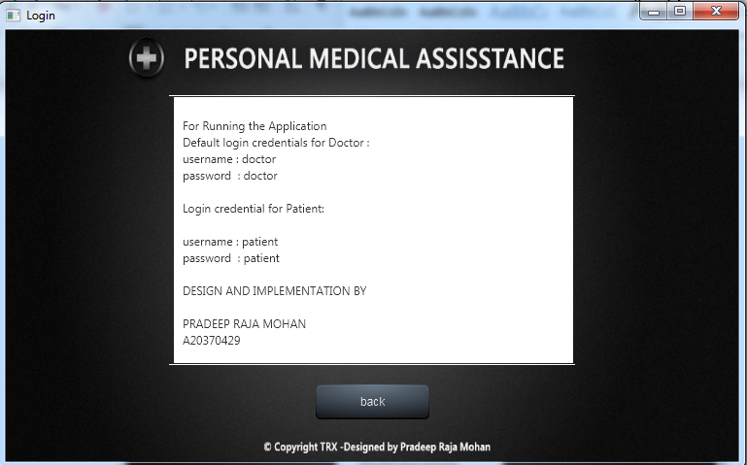

## **LOGIN SCREEN**

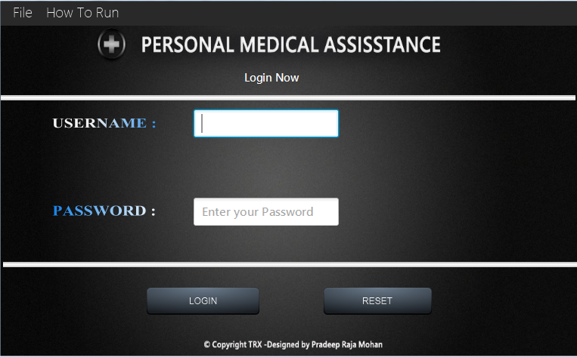

## **DOCTOR PORTAL**

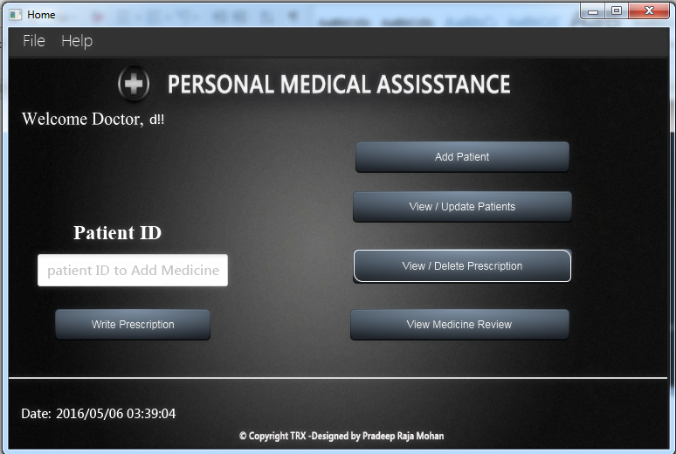

## **ADD PATIENT**

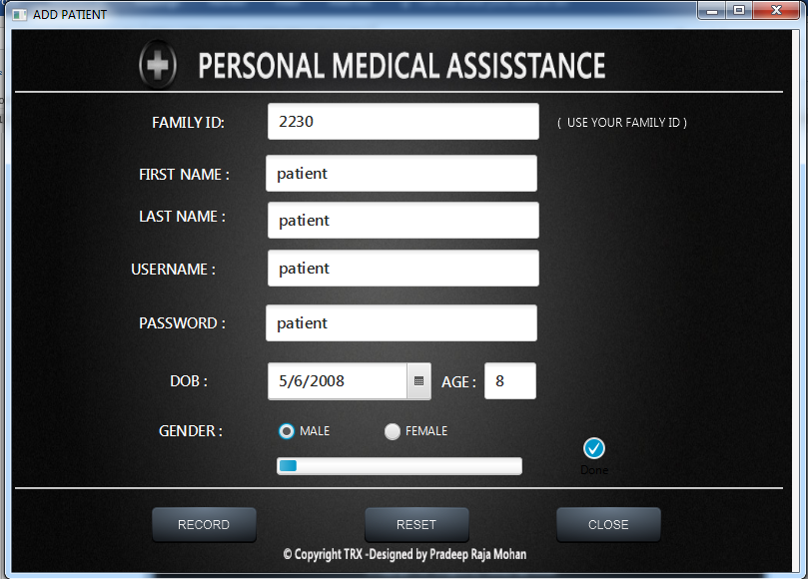

## **RECORD ADDED**

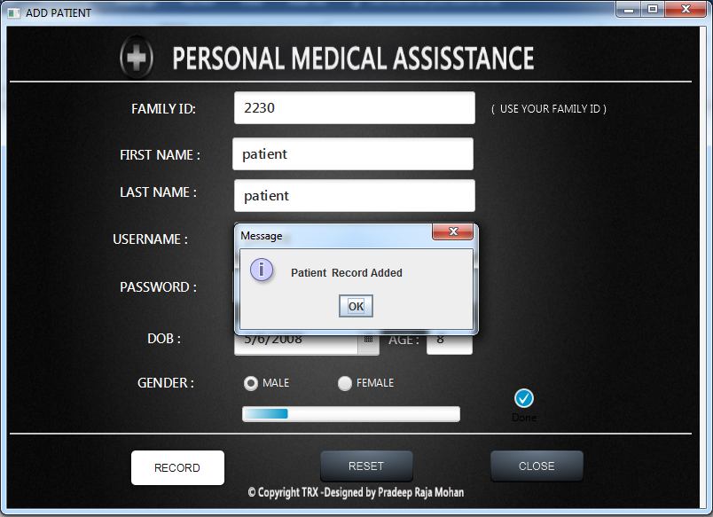

## **VIEW PATIENTS**

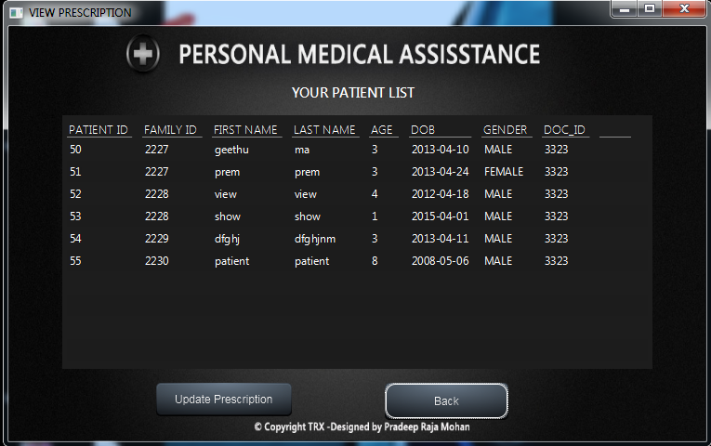

## **UPDATE PRESCRIPTION FROM TABLE**

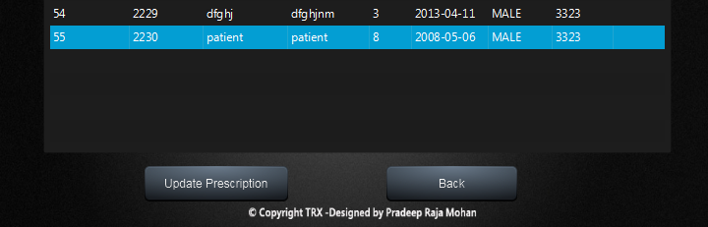

## **PRESCRIPTION UPDATE**

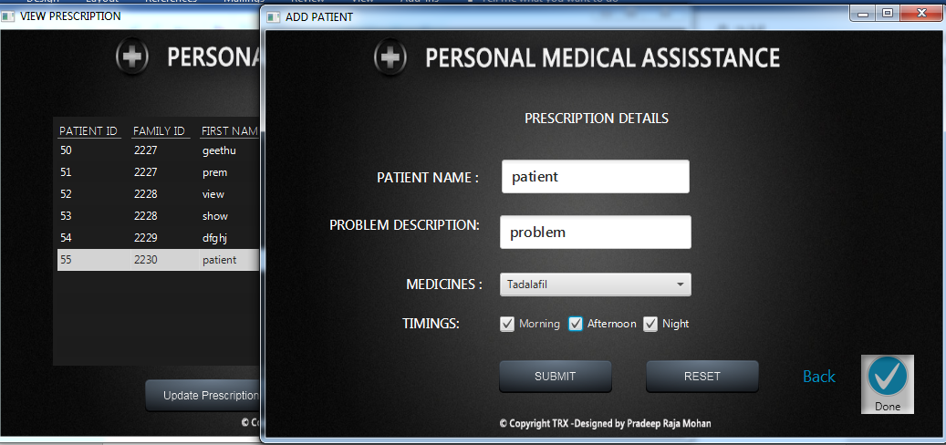

## **VIEW PRESCRIPTION**

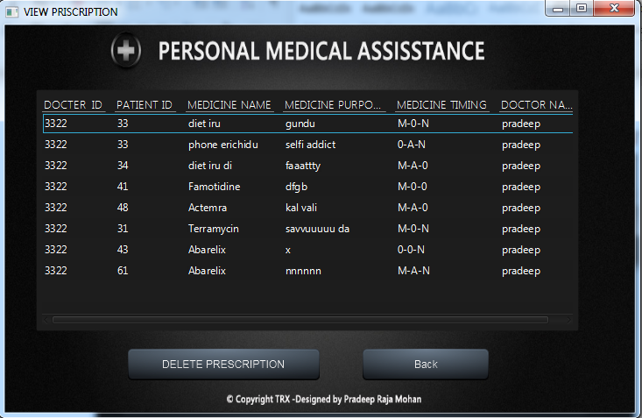

## **VIEW MEDICINE REVIEW**

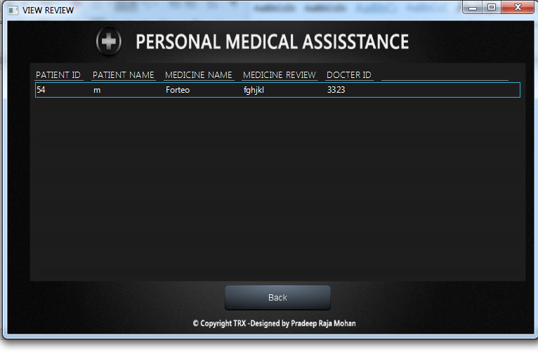

## **WRITE PRESCRIPTION – ENTER PATIENT ID**

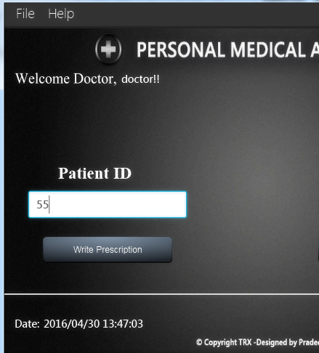

## **DISPLAYING DETAILS OF THE PATIENT**

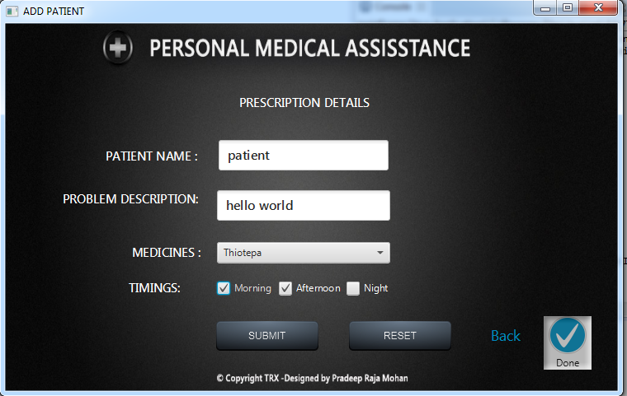

## **PATIENT LOGIN**

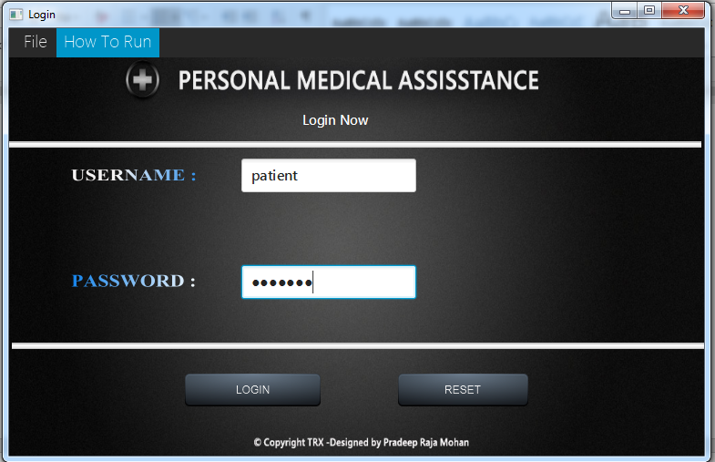

## **PATIENT INTERFACE**

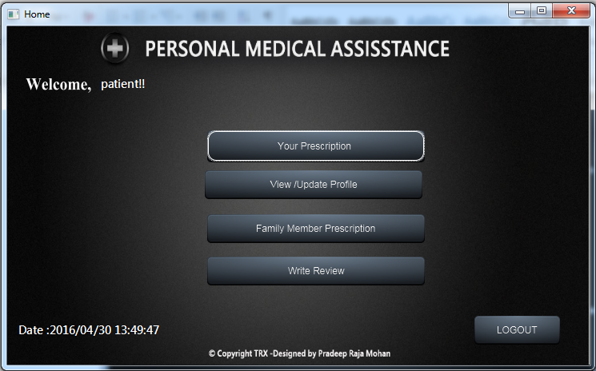

## **VIEW YOUR PRESCRIPTION**

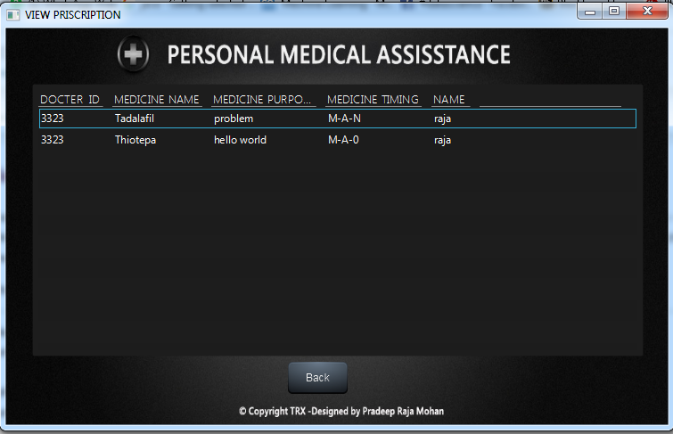

## **VIEW UPDATE PROFILE**

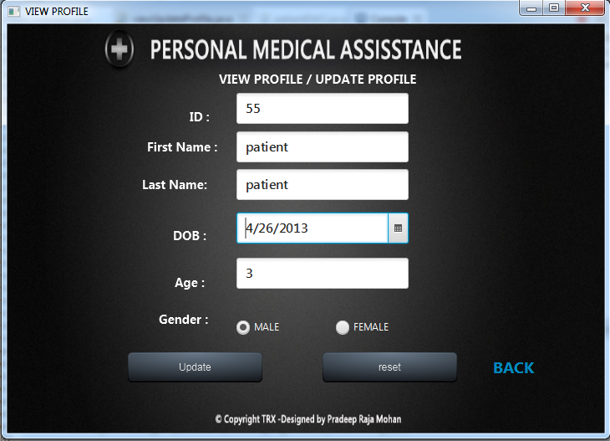

## **UPDATE DONE**

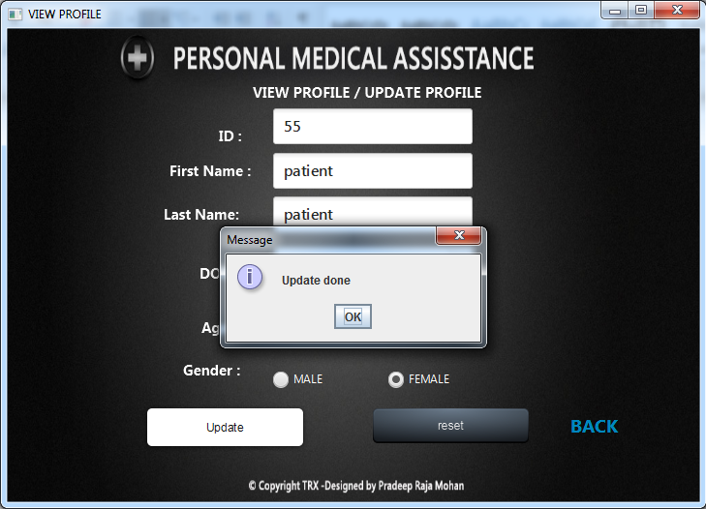

## **VIEW FAMILY PRESCRIPTION**

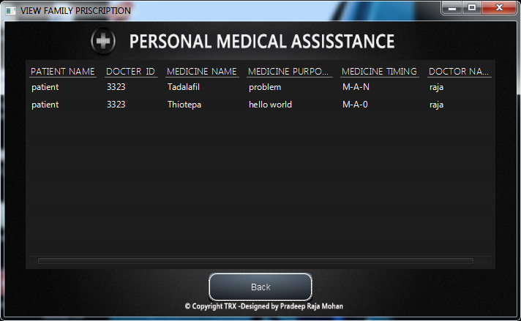

## **WRITE REVIEW**

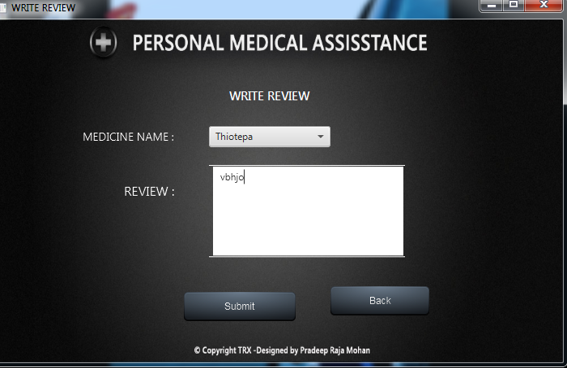

## **VALIDATIONS :**

**USERNAME AND PASSWORD VALIDATION**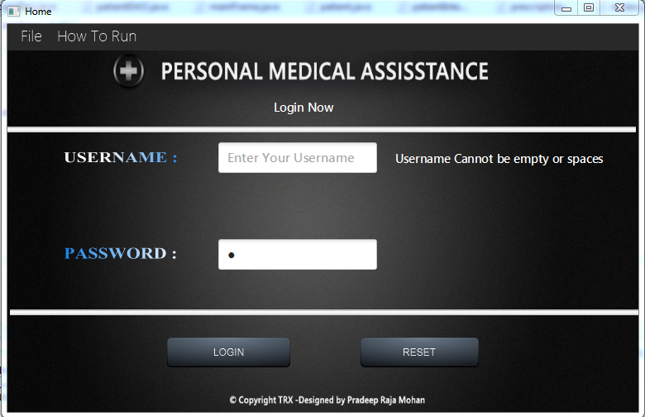

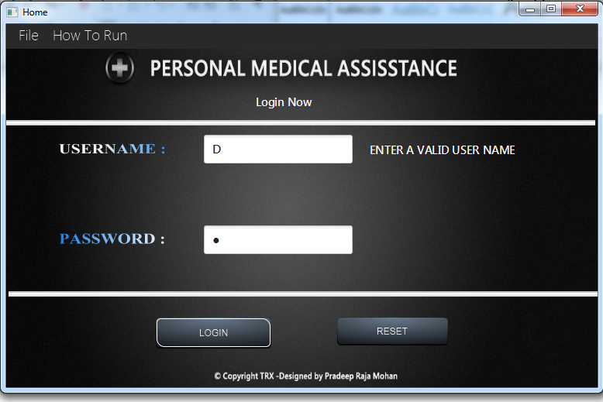

## **CUSTOMER ADDING**

